Student’s Name
Professor’s Name
Course
Title

Description of Automotive Piston
General Description
Automotive piston is a metal disc used to support engines, pumps, gas compressors and various types of cylinders. Pistons are made from aluminum alloys so that they can lengthen and avoid fatigue in racing pistons. Furthermore, those early pistons were made from iron so as to produce engines that would survive high combustion temperatures. With time, it became necessary to use alloys such as Y alloy and Hidumium. Pistons are used in engines to transfer force from expanding gas in crankshaft through a piston rod. In addition to this, automotive piston ring seals the combustion chamber through applied pressure. Also, long pistons are used in supporting combustion engines so as to make work easier. Through this, there is minimal wastage of gases to the crank thus proper maintenance of enough oil in the cylinder. An automotive piston comprises of the piston, compression rings, piston pins and piston skirts and connection rod.
Parts of an Automotive Piston
Cylinder is the piston part that is at the top end and is enclosed with fuel injectors, air injectors and a poking through spark.
Piston rings are the major parts of a piston system. It is located below and fuel can be injected and it can move up and down with a lot of ease in the cylinder. In addition to that, it creates a seal between the edge of the piston and the edge of the cylinder so as to avoid explosion.
Fuel and air injector do allow both air and fuel so as to ensure the correct amount of oxygen and gasoline gas into the cylinder.
Spark plug is a device with electrode protruding into the cylinder so as to create a spark that ignites the fuel thus leading to a small explosion.
Principles of operation
Intake
The air and fuel mixture is drawn into the crankcase by the vacuum that is created during the upward stroke of the piston (Szmytka et al., 52). The poppet engine valve use a rotary value fixed to the crankshaft.
Compression
During the downward stroke, the poppet valve is forced by the increased crankcase pressure. Afterwards, the fuel mixture is compressed in the crankcase during the remainder of the stroke.
Power
At the top of the stroke, the fuel mixture is ignited by the spark plug. The burning fuel expands, which drives the piston downward, which helps to complete the cycle.
Exhaust
During the exhaust stroke the piston once again returns the top dead center while the exhaust valve is open. Through this action, there is evacuation of burnt products of combustion from the cylinder by expelling the used up fuel mixture through the exhaust valve outside.

Side view of piston and connection rod
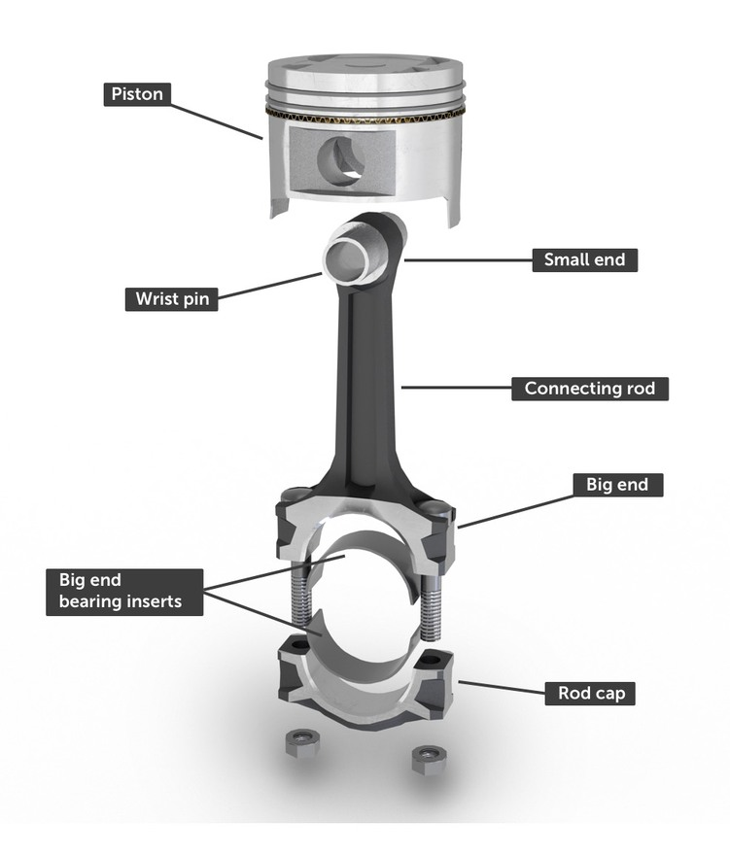

Piston Shape
An automotive piston is designed in such a shape that enables it to work effectively. Since pistons are subjected to a lot of heat, movement and high pressure, they therefore ought to be made durable. Pistons are oval shaped. This shape gives pistons a chance to improve sealing and thus enhancing its efficiency also, there are pistons which are conically shaped, so as to enable the piston to work freely. Finally, some pistons are barrel shaped thus are smoother and does not produce a lot of noise.
Piston Mode of attachment
Pistons do have a special way with which each of their parts are assembled in order to ensure its effective use. The piston pin is slid and through this, the piston and connecting rod are assembled. A wooden dowel is very important when it comes to tapping the piston pin into its right place. In addition to all these, doing this in practice is very necessary.
Piston parts
Piston is made up of several parts that do work together to ensure its efficiency. Automotive piston has a piston as a major part. This piston plays a big role in transferring the chemical energy that is in the fuel. The energy is necessary in the mechanical process of a piston. The other part is the cylinder, which is found at the top of the fuel injector. Fuel injector is the other part that do help in the control of oxygen amount. It does this by ensuring that when it squirts, it gives the right proportion of oxygen. Spark plug is that part of the automotive piston and its role is to enable the electrode protruding into the cylinder each time the injector releases both fuel and air into the cylinder. Finally, crankshaft is the part with which a rod hinge connects the piston at both ends. This enhances the efficiency of the automotive piston. Each time a piston is pressed downwards, the crankshaft gives an effect of getting pushed around in a single direction. The energy here is important in the movement of the crankshaft. Therefore, crankshaft do make a complete turn so as to enable the piston get back and in an upward manner inside the cylinder making a complete turn.

Piston relation of adjoining parts
This is best given by use of a diagram. Below is a clear diagram to show the adjoining parts.

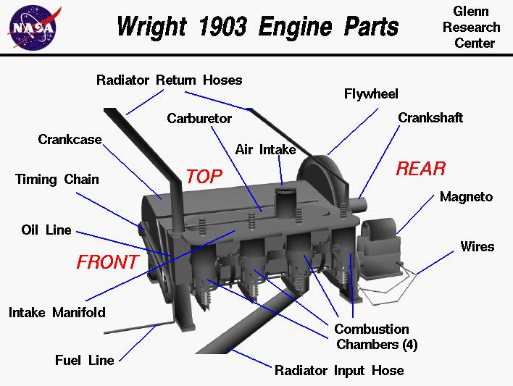

Works Cited
Hanipah, M. Razali, R. Mikalsen, and A. P. Roskilly. "Recent commercial free-piston engine developments for automotive applications." Applied Thermal Engineering 75 (2015): 493-503.
Sotomayor, Paul Ortega, and José Alberto Reis Parise. "Characterization and simulation of an open piston compressor for application on automotive air-conditioning systems operating with R134a, R1234yf and R290." International Journal of Refrigeration 61 (2016): 100-116. automotive pistons." Materials & Design 88 (2015): 1201-1209.
Sundararajan, G., S. V. Joshi, and L. Rama Krishna. "Engineered surfaces for automotive engine and power train components." Current opinion in chemical engineering 11 (2016): 1-6.
Szmytka, F., et al. "Thermal fatigue analysis of automotive diesel piston: Experimental procedure and numerical protocol." International Journal of Fatigue 73 (2015): 48-57.
Wong, Victor W., and Simon C. Tung. "Overview of automotive engine friction and reduction trends–Effects of surface, material, and lubricant-additive technologies." Friction 4.1 (2016): 1-28.

